A
Real-Time Research Project On

WEAPON DETECTION USING

FASTER RCNN OR FRCNN
(Submitted in partial fulfillment of the requirements for the award of Degree)

BACHELOR OF TECHNOLOGY
In

COMPUTER SCIENCE AND ENGINEERING
By
- Nithin Reddy 247R1A05BD
N.Sailaja Reddy 247R1A05BR
N.Sravanthi 247R1A05BU

Under the Guidance of

Ms.J.SWARNALATHA
Assistant Professor


DEPARTMENT OF COMPUTER SCIENCE AND ENGINEERING
CMR TECHNICAL CAMPUS
UGC AUTONOMOUS
(Accredited by NAAC, NBA, Permanently Affiliated to JNTUH, Approved by AICTE, New Delhi)
Recognized Under Section 2(f) & 12(B) of the UGCAct.1956, Kandlakoya (V), Medchal Road, Hyderabad-501401.
April, 2026.

DEPARTMENT OF COMPUTER SCIENCE AND ENGINEERING



CERTIFICATE

This is to certify that the project entitled “Weapon Detection using Faster RCNN
(FRCNN) Algorithms” being submitted by K.NITHIN REDDY (247R1A05BD),
REDDY (247R1A05BR) & N.SRAVANTHI (247R1A05BU) in partial fulfillment of the requirements for the award of the degree of B.Tech in Computer Science and Engineering to the Jawaharlal Nehru Technological University Hyderabad, during the year 2025-26.

The results embodied in this thesis have not been submitted to any other University or Institute for the award of any degree or diploma.

Ms. J. Swarnalatha Dr. Nuthanakanti Bhaskar Assistant Professor HoD
INTERNAL GUIDE

ACKNOWLEDGEMENT
We take this opportunity to express our gratitude to the people who have been instrumental in the successful completion of this project, we take this opportunity to express our profound gratitude and deep regard to our guide Ms. J. Swarnalatha, Assistant Professor for his exemplary guidance, monitoring and constant encouragement throughout the project work. The blessing, help and guidance given by him shall carry us a long way in the journey of life on which we are about to embark.

We take this opportunity to extend our heartfelt appreciation to the Project Review Committee (PRC) Coordinators—Dr. J. Narasimharao, Mrs. M. Srilekha, Dr. G. Venkateshwarlu Naik, and Mrs. A. Divya Bharathi—for their unwavering support, insightful guidance, and valuable inputs, which played a crucial role in steering this project through its various stages.

Our sincere appreciation also goes to Dr. Nuthanakanti Bhaskar, Head, for his encouragement and continuous support in ensuring the successful completion of our project.

We are deeply grateful to Dr. A. Raji Reddy, Director, for his cooperation throughout the course of this project. Additionally, we extend our profound gratitude to Sri. Ch. Gopal Reddy, Chairman, Smt. C. Vasantha Latha, Secretary and Sri. C. Abhinav Reddy, Vice-Chairman, for fostering an excellent infrastructure and a conducive learning environment that greatly contributed to our progress.

We also acknowledge and appreciate the guidance and assistance provided by the faculty and staff of CMR Technical Campus, whose contributions have been invaluable in bringing this project to fruition.
Lastly, we sincerely thank our families for their unwavering support and encouragement. We also extend our gratitude to the teaching and non-teaching staff of CMR Technical Campus for their guidance and assistance. Their contributions, along with the support of everyone who helped directly or indirectly, have been invaluable in the successful completion of this project.

K. Nithin Reddy (247R1A05BD)
N.Sailaja Reddy (247R1A05BR) N.Sravanthi (247R1A05BU)

VISION AND MISSION

INSTITUTE VISION:
To Impart quality education in serene atmosphere thus strive for excellence in Technology and Research.

INSTITUTE MISSION:
- To create state of art facilities for effective Teaching- Learning Process.

- Pursue and Disseminate Knowledge based research to meet the needs of Industry & Society.

- Infuse Professional, Ethical and Societal values among Learning Community.

DEPARTMENT VISION:
To provide quality education and a conducive learning environment in computer engineering that foster critical thinking, creativity, and practical problem-solving skills.

DEPARTMENT MISSION:
- To educate the students in fundamental principles of computing and induce the skills needed to solve practical problems.

- To provide State-of-the-art computing laboratory facilities to promote industry institute interaction to enhance student’s practical knowledge.

- To inculcate self-learning abilities, team spirit, and professional ethics among the students to serve society.

ABSTRACT

Security has become a critical concern across all domains due to the rapid increase in crime rates, particularly in crowded public events and isolated areas where monitoring is challenging. Ensuring public safety, protecting personal property, and maintaining law and order require intelligent and automated surveillance solutions.
In this context, abnormal activity detection and continuous monitoring have emerged as significant applications of computer vision, helping to address a wide range of security-related challenges.With the growing demand for advanced safety mechanisms, modern video surveillance systems must not only capture footage but also analyze and interpret scenes in real time. The ability to automatically detect suspicious objects and identify anomaly events plays a vital role in intelligent monitoring systems.
Automated weapon detection, especially gun detection, is one of the most crucial tasks in proactive threat prevention.This paper presents an implementation of automatic gun (or) weapon detection using the Faster R-CNN algorithm, a deep learning–based object detection model known for its accuracy in identifying objects within images. The proposed system utilizes two different types of datasets. The first dataset consists of per-labelled images that are readily available for training and evaluation.
The second dataset comprises manually labeled images, prepared to enhance model robustness and improve detection performance under diverse real-world conditions.The experimental results are carefully tabulated and analyzed. Both trained models demonstrate strong detection accuracy and reliable performance. However, when deploying such systems in real-world scenarios, the choice of algorithm must consider the trade-off between detection speed and accuracy. While higher accuracy improves reliability, faster processing is essential for real-time surveillance applications.
Therefore, selecting the appropriate model depends on the specific operational requirements and constraints of the deployment environment.

LIST OF FIGURES

FIGURE NO FIGURE NAME PAGE NO

Figure 3.2
This project architecture shows the workflow of the weapon detection system from input to output. Data is preprocessed and passed to the Faster R-CNN model for detection.
8
.

Figure 3.2
A Data Flow Diagram (DFD) is a graphical representation that illustrates how data flows within the weapon detection system. It provides a clear view of how input data is processed.

14

Figure 4.1

18
The dataset contains two folders: ‘Weapon’ and ‘Non-Weapon’ with labeled images. This helps the model learn and classify objects accurately.

Figure 4.2

The dataset images include various scenes containing weapons and non-weapon objects under different conditions. These images vary in background, lighting, and object orientation to help the model learn accurately.
18

Figure 5.1
The image shows the main interface of the weapon detection system with different operation buttons. It allows users to upload data, train the model, and perform detection easily.

35

Figure 5.2.1

The image shows the dataset selection window where the user can choose the folder containing annotation files. It allows easy browsing and uploading of the dataset into the system.
36

Figure 5.2.2

The image shows the system interface after initiating dataset upload. It indicates that the application is ready to load and process the selected dataset for further operations.

36

Figure 5.4
Weapon detection GUI with controls for dataset upload, model generation, and image/video detection.Shows FRCNN performance metrics and confirms the model is loaded.
37

Figure 5.5

FRCNN training graphs showing accuracy increasing and loss decreasing over epochs.Indicates model improvement with higher accuracy and lower loss.

38

Figure 5.6

File explorer window for selecting test images to upload into the weapon detection system.Displays multiple image options with preview thumbnails and an open button.
38
Figure 5.7
Weapon detection system displaying an uploaded image with detected weapon highlighted.GUI includes controls for dataset upload, model loading, and detection options.
39

Figure 5.8

Uploading videos for frame-by-frame weapon detection using the Faster R-CNN model.This model processes each frame to identify and highlight detected weapons.
40

Figure 5.9

Output of video-based weapon detection showing frame-by-frame analysis results. Detected weapons are highlighted across video frames using the Faster R-CNN model.
40

 | LIST OF TABLES
TABLE NO | TABLE NAME | PAGE NO
Table 6.2.4 | Test Cases | 41

v

TABLE OF CONTENTS

ABSTRACT i
LIST OF FIGURES ii
LIST OF TABLES v
- INTRODUCTION 1
  - PROJECT PURPOSE 1
  - PROJECT FEATURES 2
- LITERATURE SURVEY 3
  - REVIEW OF RELATED WORK 5
  - DEFINITION OF PROBLEM STATEMENT 7
  - EXISTING SYSTEM 8
  - PROPOSED SYSTEM 9
  - OBJECTIVES 9
  - HARDWARE & SOFTWARE REQUIREMENTS 10
    - HARDWARE REQUIREMENTS 10
    - SOFTWARE REQUIREMENTS 10
- SYSTEM ARCHITECTURE & DESIGN 11
  - PROJECT ARCHITECTURE 11
  - DESCRIPTION 12
  - DATA FLOW DIAGRAM 13
- IMPLEMENTATION 15
  - ALGORITHMS USED 15
  - SAMPLE CODE 19
- RESULTS & DISCUSSION 34
- VALIDATION 40
  - INTRODUCTION 40
  - TEST CASES 41
- CONCLUSION & FUTURE ASPECTS 42
  - PROJECT CONCLUSION 42
  - FUTURE ASPECTS 43
- BIBLIOGRAPHY 44
  - REFERENCES 44
  - GITHUB LINK 45

1.INTRODUCTION

INTRODUCTION

Security has become one of the most significant concerns in today’s world due to the increasing number of violent incidents, weapon-related crimes, and unexpected threats in public and private environments. Rapid urbanization, population growth, and large public gatherings have made it essential to implement advanced surveillance systems capable of ensuring public safety. Places such as airports, railway stations, shopping malls, educational institutions, corporate offices, banks, and government organizations require continuous monitoring to prevent dangerous situations and respond quickly to potential threats.
Traditional surveillance systems primarily depend on Closed-Circuit Television (CCTV) cameras monitored by human operators. Although these systems provide continuous video recording, they rely heavily on manual observation. Monitoring multiple video feeds for extended periods can lead to fatigue, reduced attention, and delayed responses. In crowded or complex scenes, identifying small or partially concealed weapons becomes extremely difficult. As a result, solely relying on manual surveillance is no longer sufficient for modern security demands.
1.1 PROJECT PURPOSE :
The primary objective of this project is to develop an intelligent and automated weapon detection system using deep learning techniques to enhance modern surveillance systems. The system aims to accurately detect and localize weapons such as guns in images and video streams using the Faster R-CNN algorithm.
Another key objective is to reduce dependency on manual monitoring of CCTV footage by introducing an automated detection mechanism that can analyze visual data in real time. By identifying potential threats quickly and accurately, the system helps improve response time during critical situations and strengthens overall security operations.

The project also aims to train the detection model using properly annotated datasets containing bounding box information, enabling precise localization of weapons within a frame. The system is designed to generate confidence scores and performance metrics such as accuracy and loss graphs to evaluate and improve model reliability.
Additionally, the project seeks to create a scalable solution that can be integrated with existing surveillance infrastructure in environments such as educational institutions, public transport hubs, corporate offices, and smart city monitoring systems. By leveraging advanced object detection techniques, the objective is to contribute to safer and more efficient security management.

1.2 PROJECT FEATURES :

The Project Focuses On Developing An Intelligent Weapon Detection System Using Deep Learning Techniques. It Utilizes The Faster R-CNN Algorithm To Accurately Detect And Localize Weapons In Images And Video Streams. This Helps In Improving Surveillance Efficiency And Reducing Manual Monitoring Efforts.
The System Includes Multiple Functional Modules Such As Dataset Upload, Preprocessing, Model Training, And Detection. Users Can Easily Upload Annotated Datasets, Train The Model, And Perform Weapon Detection On Images And Videos Through A User-Friendly Interface.
The Model Is Designed To Provide High Accuracy With Bounding Box Detection And Confidence Scores. It Also Generates Performance Metrics Such As Accuracy, Precision, Recall, And Loss Graphs To Evaluate And Improve The Model Performance Effectively.
The Project Supports Real-Time Or Near Real-Time Detection, Making It Suitable For Security Applications In Public Places. It Is Scalable And Can Be Integrated With Existing Surveillance Systems To Enhance Safety And Enable Faster Threat Identification.

LITERATURE SURVEY

2.LITERATURE SURVEY

With the increasing need for public safety and surveillance, automated weapon detection has become an essential research area in computer vision. Traditional surveillance systems rely heavily on human monitoring, which is often inefficient and prone to errors. This has led to the adoption of machine learning and deep learning techniques to detect weapons such as guns in images and video streams, enabling faster response and improved security.
This literature survey reviews various research works related to object detection and weapon detection, focusing on traditional machine learning models, deep learning approaches, and advanced object detection algorithms. It highlights different methodologies, their advantages, limitations, and the need for more accurate and real-time detection systems in surveillance applications.
Early research in object detection mainly used traditional machine learning techniques such as Support Vector Machines, Decision Trees, and feature-based methods. These approaches relied on handcrafted features like edges, textures, and color patterns to identify objects. Although these methods were simple to implement, they showed limited accuracy and were not suitable for complex real-world environments.
With the advancement of deep learning, Convolutional Neural Networks (CNNs) significantly improved object detection performance by automatically extracting features from images. Models like R-CNN and Fast R-CNN introduced region-based detection methods, improving accuracy but suffering from slow processing speed. These limitations led to the development of Faster R-CNN, which introduced Region Proposal Networks (RPN) for efficient and faster object detection.
Another important approach is the Single Shot Detector (SSD), which performs object detection in a single forward pass, making it faster than region-based methods. SSD achieved competitive accuracy while providing real-time detection capabilities. However, it sometimes struggles with detecting small objects compared to Faster R-CNN.
Recent research has also explored algorithms like YOLO (You Only Look Once), which provides high-speed object detection by processing the entire image in one pass. YOLO is highly efficient for real-
time applications but may compromise accuracy in complex scenes. These comparisons highlight the trade-off between speed and accuracy in object detection models.
In the context of surveillance, anomaly detection techniques have also been studied to identify unusual activities in video streams. These methods analyze patterns and detect deviations, helping in identifying suspicious behavior. However, they may not always precisely identify specific objects like weapons.
To overcome the limitations of individual models, researchers have focused on improving detection accuracy by using better datasets, feature extraction techniques, and model optimization. The use of annotated datasets with bounding boxes has significantly enhanced object localization and classification performance.
Despite these advancements, challenges such as detecting small or partially hidden weapons, varying lighting conditions, and real-time processing still exist. Therefore, the proposed system uses the Faster R-CNN algorithm, which provides a balance between accuracy and speed, making it suitable for practical surveillance applications.
Overall, the literature survey shows the evolution of object detection techniques from traditional machine learning to advanced deep learning models. Faster R-CNN stands out as a reliable approach for accurate weapon detection, and the proposed system builds upon these advancements to develop an efficient and scalable surveillance solution.
In recent years, the availability of large-scale datasets such as COCO and ImageNet has significantly contributed to the improvement of object detection models. These datasets provide diverse training samples that help models generalize better to real-world scenarios. In weapon detection, the use of both pre-labelled and manually annotated datasets has been found to improve detection robustness and accuracy.
Transfer learning has also played a crucial role in enhancing object detection performance. Instead of training models from scratch, pre-trained networks are fine-tuned on specific datasets, reducing training time and computational cost. This approach is especially useful in weapon detection, where collecting large amounts of labeled data can be challenging.
Another important development is the use of data augmentation techniques, such as rotation, scaling, and flipping, to artificially increase the size of the training dataset. These techniques help models handle variations in object orientation, lighting conditions, and background complexity, thereby improving detection accuracy in diverse environments.
Recent studies have also focused on improving real-time detection capabilities by optimizing model architectures and using hardware acceleration such as GPUs. Efficient implementation of deep learning models ensures that surveillance systems can process video frames quickly without significant delays, which is critical in security applications.
Edge computing has emerged as a promising approach for deploying detection models directly on devices such as cameras and embedded systems. This reduces latency and dependency on cloud processing, enabling faster decision-making in critical situations like threat detection in public areas.
Another area of research is the integration of alert systems with detection models. When a weapon is detected, the system can automatically trigger alarms or send notifications to authorities. This integration enhances the practical usability of detection systems in real-world security scenarios.
Explainable Artificial Intelligence (XAI) techniques are also gaining importance in object detection systems. Methods like Grad-CAM help visualize which parts of the image contributed to the model's decision, improving transparency and trust in AI-based surveillance systems.
Finally, researchers are exploring multi-object detection and tracking systems, where multiple objects, including weapons, can be detected and tracked simultaneously in video streams. This helps in monitoring crowded environments more effectively and ensures continuous tracking of potential threats across frames.
2.1 REVIEW OF RELATED WORK
The detection and identification of weapons in images and videos have been widely studied in the fields of computer vision and deep learning. Various approaches have been proposed over the years, ranging from traditional image processing techniques to advanced deep learning-based object detection models. This section reviews existing methodologies and highlights their advantages and limitations in weapon detection systems.

1.Traditional Detection Approaches
Early weapon detection systems relied on manual surveillance and basic image processing techniques. These approaches used edge detection, shape analysis, and predefined rules to identify objects resembling weapons. While simple to implement, these methods lacked robustness and failed in complex environments with varying lighting conditions, backgrounds, and object orientations.
2.Machine Learning-Based Approaches
With the advancement of machine learning, researchers introduced classification models such as Support Vector Machines (SVM), Decision Trees, and Random Forest. These methods utilized handcrafted features like texture, color patterns, and object shapes to detect weapons. Although these approaches improved detection compared to traditional methods, they suffered from limited accuracy and poor generalization when applied to real-world datasets.
3.Deep Learning-Based Approaches
The introduction of deep learning significantly enhanced weapon detection performance. Convolutional Neural Networks (CNNs) enabled automatic feature extraction from images, improving classification accuracy. Region-based models such as R-CNN and Fast R-CNN further improved object localization but were computationally expensive and slow for real-time applications.
Faster R-CNN addressed these limitations by introducing Region Proposal Networks (RPN), enabling faster and more accurate object detection. This model has become widely used in weapon detection due to its ability to generate bounding boxes and confidence scores effectively. Despite its high accuracy, Faster R-CNN requires considerable computational resources and training data.
4.Recent Advances in Object Detection
Recent advancements include single-stage detectors such as YOLO (You Only Look Once) and SSD (Single Shot Detector), which provide faster detection suitable for real-time applications. YOLO processes the entire image in a single pass, achieving high speed, while SSD balances speed and accuracy. However, these models may struggle with detecting small or partially visible weapons compared to region-based approaches.
Additionally, improvements in dataset annotation, transfer learning, and model optimization have contributed to better detection performance. The use of pre-trained models and fine-tuning techniques has reduced training time while maintaining high accuracy.
Comparison with the Proposed Approach
Although existing methods have achieved significant progress, challenges such as detecting concealed weapons, handling complex backgrounds, and achieving real-time performance still remain. The proposed system utilizes the Faster R-CNN algorithm to overcome these limitations by providing high detection accuracy along with reliable object localization. Compared to traditional and machine learning approaches, this method offers improved performance, reduced human intervention, and better adaptability to real-world surveillance scenarios.
This review highlights the evolution of weapon detection techniques from basic image processing methods to advanced deep learning models. The proposed approach builds upon these advancements to develop an efficient, accurate, and scalable weapon detection system suitable for modern security applications.

2.2 DEFINITION OF PROBLEM STATEMENT
The primary goal of this project is to develop a robust and efficient deep learning-based system capable of accurately detecting and localizing weapons in images and video streams. The system aims to identify potentially dangerous objects such as guns in real-time surveillance scenarios, ensuring improved public safety and faster threat response.
This involves challenges such as detecting small or partially hidden weapons, handling variations in lighting conditions, and processing complex backgrounds in real-world environments. Additionally, the system must ensure high accuracy while maintaining reasonable processing speed for practical deployment.
By addressing these challenges, the proposed system aims to reduce dependency on manual monitoring, enhance surveillance efficiency, and provide a scalable solution that can be integrated into modern security systems for proactive threat detection.
2.3 EXISTING SYSTEM

The existing systems for weapon detection primarily rely on traditional surveillance methods combined with basic image processing and machine learning techniques. Earlier approaches used feature extraction methods such as edge detection, shape analysis, and color-based segmentation to identify weapon-like objects. These features were then classified using machine learning algorithms like Support Vector Machines (SVM), Decision Trees, and Random Forest classifiers. In some systems, object detection was performed using Haar Cascade classifiers and handcrafted features to detect weapons in images and video frames.
With the advancement of computer vision, deep learning-based approaches such as Convolutional Neural Networks (CNNs) were introduced to improve detection accuracy. Region-based models like R-CNN and Fast R-CNN were used to identify and localize objects within images. Additionally, single-stage detectors such as YOLO and SSD were employed for faster detection in real-time applications. These systems analyze visual data frame-by-frame and generate predictions based on trained datasets, sometimes combined with motion detection techniques in video surveillance.
Some advanced systems also integrate video analysis by processing frames sequentially to detect suspicious objects across time. These systems may include bounding box detection, confidence scoring, and basic tracking mechanisms. However, most existing approaches focus either on speed or accuracy, often struggling to achieve both simultaneously in real-world environments.
Limitations of Existing System
Despite advancements in detection techniques, the existing systems suffer from several challenges:
Inability to detect small or partially hidden weapons: Many models fail to accurately identify weapons when they are occluded, blurred, or present in complex backgrounds.
Trade-off between speed and accuracy: Faster models like YOLO provide real-time detection but may compromise accuracy, while models like R-CNN offer higher accuracy but are slower.
Computational complexity: Deep learning models require high processing power and GPU support, making real-time deployment difficult on low-resource systems.
Limited generalization: Models trained on specific datasets may not perform well in diverse real-world scenarios with varying lighting conditions and environments.
Overall, while existing systems have improved weapon detection capabilities, they still face challenges in achieving reliable, accurate, and real-time performance in practical surveillance applications.
2.4 PROPOSED SYSTEM :
The system uses a Faster R-CNN deep learning model to detect and localize weapons in images and videos, generating bounding boxes and confidence scores. It leverages annotated datasets to improve accuracy and works effectively under varied real-world conditions.
It includes modules for data processing, model training, and image/video detection, with frame-by-frame video analysis. Performance is evaluated using accuracy, precision, recall, and loss, and the trained model can be saved for efficient reuse.
Advantages of the Proposed System:
- Higher accuracy with precise bounding boxes and confidence scores for reliable detection.
- Supports near real-time image and video processing for surveillance use.
- Robust performance across varying conditions using annotated datasets and preprocessing.
- Scalable system that can integrate with large datasets and security infrastructures.
- Reduces human effort through automated detection of potential threats.
2.5 OBJECTIVES OF PROPOSED SYSTEM :
- Detect and localize weapons in images and videos using Faster R-CNN.
- Provide accurate predictions with bounding boxes and confidence scores.
- Enable near real-time detection for surveillance applications.
- Improve robustness under varying lighting, background, and orientations.
- Utilize annotated datasets for better training and performance.
- Support both image-based and video-based weapon detection.
- Allow model saving and loading for reuse without retraining.
- Ensure scalability for large datasets and system integration.
- Minimize human effort through automated threat detection.

2.6 HARDWARE & SOFTWARE REQUIREMENTS
2.6.1 HARDWARE REQUIREMENTS:
Hardware requirements define the physical components necessary for the proper functioning of the weapon detection system. These components ensure smooth execution of deep learning models and efficient processing of image and video data. The following are the hardware requirements:
- Processor - Intel Core i3 (minimum)
- Hard Disk - 500 GB
- RAM - 4 GB (minimum)
- Input Devices - Keyboard and Mouse
- Display - Standard Monitor (SVGA)
2.6.2 SOFTWARE REQUIREMENTS:
Software requirements specify the system software and tools required to develop and execute the proposed weapon detection system. These components support model training, image processing, and user interaction. The following are the software requirements:
- Operating System - Windows 10 (minimum)
- Programming Language - Python
- Libraries/Frameworks - OpenCV, TensorFlow, Keras, NumPy, Pandas, Scikit-learn
- Development Environment - Python IDE (Anaconda / Jupyter / PyCharm)
- User Interface - Tkinter (for GUI-based interaction)

SYSTEM ARCHITECTURE &
DESIGN

3. SYSTEM ARCHITECTURE & DESIGN

Project architecture refers to the structural framework and design of a project, encompassing its components, interactions, and overall organization. It provides a clear blueprint for development, ensuring efficiency, scalability, and alignment with project goals. Effective architecture guides the project's lifecycle, from planning to execution, enhancing collaboration and reducing complexity.

3.1 PROJECT ARCHITECTURE
This project architecture shows the workflow of the weapon detection system from input to output. Data is preprocessed and passed to the Faster R-CNN model for detection.The system then displays results with bounding boxes and confidence scores for detected weapons.
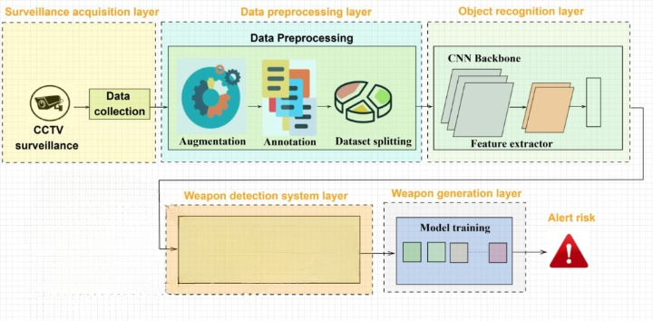
FRCNN
Figure 3.1: Project Architecture of A RCNN weapon detection model

3.2 DESCRIPTION

Input Data : The project uses image and video datasets containing weapons such as guns, which are collected from various sources and properly annotated. These datasets help the model learn to identify weapons under different conditions such as lighting, background, and object orientation.
Reading Data : The input images and video streams are processed using libraries like OpenCV. Video data is converted into frames, which are then used for further analysis and detection by the model.
Preprocessing : The extracted images and frames are resized, normalized, and cleaned to remove noise. This step ensures that the data is in a suitable format for training and improves overall model performance.
Feature Extraction : The Faster R-CNN model uses deep convolutional neural networks to automatically extract important features from images, such as edges, shapes, and textures of objects.
Object Detection : A Region Proposal Network (RPN) is used to generate candidate regions where objects may be present. These regions are then classified as weapon or non-weapon, and bounding boxes are refined for accurate localization.
Classification Layer : The detected objects are assigned labels along with confidence scores, indicating the probability of the presence of a weapon in the image or frame.
Training and Evaluation : The model is trained using annotated datasets and evaluated using performance metrics such as accuracy, precision, and recall to ensure reliable detection results.
Output : The final output displays detected weapons in images or video frames with bounding boxes and confidence scores, making it easy for users to interpret the results.

3.3 DATA FLOW DIAGRAM
A Data Flow Diagram (DFD) is a graphical representation that illustrates how data flows within the weapon detection system. It provides a clear view of how input data is processed, transformed, and converted into meaningful output. DFD is an important tool in system design as it helps in understanding the internal working of the system and the interaction between different components.

A Data Flow Diagram consists of four main components:
External Entities: These are the sources or destinations of data outside the system, such as users who provide image or video input and receive detection results.
Processes: These represent the operations performed on the data, including preprocessing, feature extraction, model training, and weapon detection.
Data Flows: These indicate the movement of data between different components, showing how input data is transformed step by step.
Data Stores: These represent storage locations such as datasets, trained models, and output files, which are used during different stages of the system.
These components are represented using standard symbols such as rectangles for external entities, circles for processes, arrows for data flows, and open-ended rectangles for data stores. This standard representation makes it easier to analyze and understand complex systems.
Benefits:
DFDs provide a visual representation of the system, making it easier for both technical and non-technical users to understand the workflow. They help in identifying inefficiencies, improving system design, and ensuring proper data handling. DFDs also assist developers in debugging and optimizing the system by clearly showing data movement and dependencies between modules.
Applications:
DFDs are widely used in software engineering, system analysis, and business process modeling. In this project, they help in visualizing how image and video data flows through different stages such as input, preprocessing, detection, and output generation. This ensures that the system is efficient, reliable, and easy to maintain.
Levels of DFD:
DFD’s are structured in multiple levels to represent the system in detail:
Level 0 (Context Diagram): This provides a high-level overview of the entire system, showing the interaction between the user and the weapon detection system. It represents the system as a single process with input and output flows.
Level 1: This level breaks down the main process into sub-processes such as data input, preprocessing, feature extraction, model training, and detection. It provides more clarity on how the system operates internally.
Level 2: This level gives a more detailed view of each sub-process, explaining individual operations like image resizing, normalization, region proposal, classification, and output generation. It is useful for understanding complex parts of the system in depth.

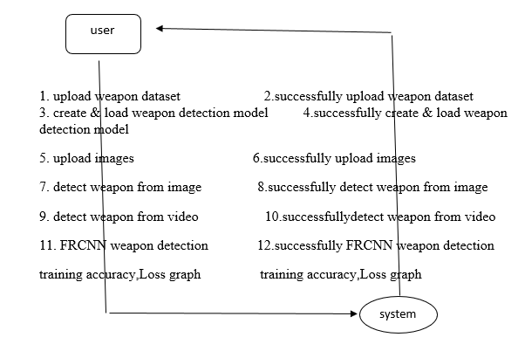
Figure 3.2: Dataflow Diagram of A RCNN weapon detection model

4.IMPLEMENTATION :
4.IMPLEMENTATION
The implementation phase of the project involves executing the designed system for weapon detection using deep learning techniques. It includes integrating different modules such as data processing, model training, and detection to ensure the system works efficiently. Proper implementation ensures that the system meets performance requirements and produces accurate results in real-time scenarios.
4.1 ALGORITHMS USED
CNN-Based Models for Feature Extraction
Convolutional Neural Networks (CNNs) are widely used in image processing and object detection tasks due to their ability to extract spatial features effectively. In this project, deep CNN layers within the Faster R-CNN model are used to identify important visual patterns such as edges, shapes, and textures related to weapons. These features help in distinguishing weapons from non-weapon objects in images and video frames.
Advantages of CNN-Based Models:
- Highly effective in detecting visual patterns such as weapon shapes and structures.
- Automatically extract features without manual intervention.
- Provide high accuracy in image-based classification tasks.
Disadvantages of CNN-Based Models:
- Require large datasets for effective training.
- Computationally intensive, especially for high-resolution images.
- Limited in handling real-time detection without optimization.
Region-Based Detection (Faster R-CNN)
Faster R-CNN is used in this project as the main object detection algorithm. It combines feature extraction with region proposal techniques to detect objects efficiently. The Region Proposal Network (RPN) identifies possible object regions, which are then classified and refined to detect weapons accurately.

Advantages of Faster R-CNN:
- Provides high accuracy in object detection tasks.
- Generates precise bounding boxes for object localization.
- Efficient compared to earlier region-based models.
Disadvantages of Faster R-CNN:
- Requires significant computational resources.
- Slower than single-stage detectors in real-time scenarios.
1.Feature Extraction using CNN :
The convolutional layers extract meaningful features from images such as edges and object shapes. These features are crucial for identifying weapons in different environments and conditions.
2.Region Proposal Network (RPN) :
The RPN generates candidate regions where objects may exist. It reduces the number of regions to be processed, improving efficiency and detection speed.
3.Classification and Localization :
The detected regions are classified as weapon or non-weapon, and bounding boxes are refined to accurately locate the objects within the image.
3.Model Training and Optimization :
The model is trained using annotated datasets with bounding boxes. Optimization techniques are applied to improve accuracy and reduce errors during detection.
4.Support Vector Machine (SVM) (Optional Comparison) :
In some cases, traditional classifiers like SVM can be used for comparison. However, SVM lacks the ability to perform object localization and does not handle complex image features effectively compared to deep learning models.
In modern surveillance systems, the need for automated weapon detection has increased due to security concerns. Manual monitoring is inefficient and prone to errors. Therefore, deep learning-based approaches like Faster R-CNN are used to improve detection accuracy and reduce human effort.The model is trained on annotated datasets and tested under various conditions to ensure reliability.
To train the model, the system uses an annotated dataset consisting of images and video frames categorized into two classes: ‘Weapon’ and ‘Non-Weapon’.
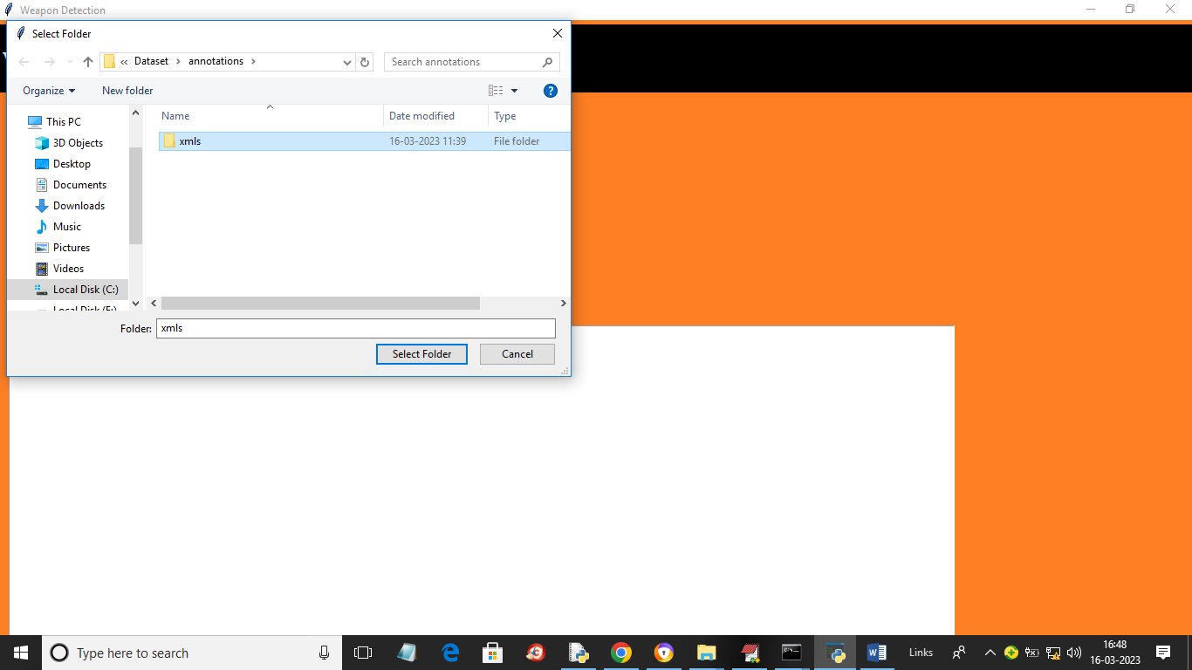
Figure 4.1: Dataset directory structure with folders 'of weapons marked manually
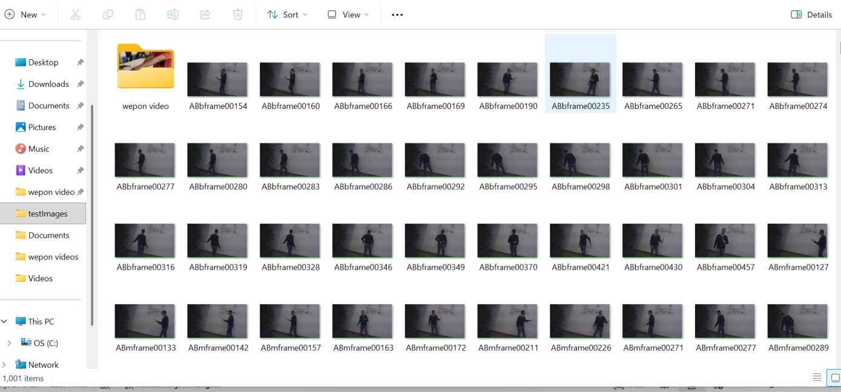
Figure 4.2: Screenshot of the weapons
These datasets are organized into separate folders, where each folder contains labeled training examples. This structured dataset helps the model learn to differentiate between weapon and non-weapon objects effectively.To implement this project, the following modules are designed:
Upload Weapon Detection Dataset:
Using this module, users can upload image or video datasets containing weapon and non-weapon classes into the application for training and testing purposes.
Dataset Preprocessing:
In this module, all images are read and resized to a uniform size. Pixel values are normalized, and the dataset is shuffled to improve model generalization and performance.
Model Training using Faster R-CNN:
The dataset is divided into training and testing sets. The training data is used to train the Faster R-CNN model, where deep convolutional layers extract features and the Region Proposal Network identifies object regions. The trained model is then tested on the remaining data to evaluate accuracy.
Model Saving and Loading:
After training, the model is saved and can be reloaded for future detection tasks without retraining, improving efficiency and usability.
Weapon Detection on Images:
This module allows users to upload images, and the system detects weapons by drawing bounding boxes and displaying confidence scores for identified objects.
Weapon Detection on Video:
In this module, video files are processed frame by frame, and the system detects weapons in real time or near real time, highlighting them in each frame.
Performance Evaluation:
The system generates performance metrics such as accuracy, precision, recall, and loss graphs to compare model performance and ensure reliable detection results.
Overall, these modules work together to provide an efficient and user-friendly system for detecting weapons in images and video streams.
4.2 Sample Code:
from tkinter import *
import tkinter
from tkinter import filedialog
from tkinter.filedialog import askopenfilename
import numpy as np
import cv2
from keras.utils.np_utils import to_categorical
from keras.layers import MaxPooling2D
from keras.layers import Dense, Dropout, Activation, Flatten
from keras.layers import Convolution2D
from keras.models import Sequential
from keras.models import model_from_json
import pickle
import os
import matplotlib.pyplot as plt
from sklearn.model_selection import train_test_split
from keras.callbacks import ModelCheckpoint
from sklearn.model_selection import train_test_split
import keras
from keras.models import Sequential, Model, load_model
from keras.layers import Conv2D, MaxPooling2D
from keras.layers import Dense, Dropout, Lambda, Activation, Flatten, Input
from keras.preprocessing.image import ImageDataGenerator
from keras.optimizers import Adam, RMSprop, SGD
from keras.utils import np_utils
from keras.utils.np_utils import to_categorical
from sklearn.metrics import accuracy_score
import xml.etree.ElementTree as ET
from sklearn.metrics import precision_score
from sklearn.metrics import recall_score
from sklearn.metrics import f1_score
from sklearn.metrics import accuracy_score
main = tkinter.Tk()
main.title("Weapon Detection")
main.geometry("1300x900")
global model, classes, layer_names, output_layers, colors, filename
X = []
Y = []
bb = []
#function to normalize bounding boxes
def convert_bb(img, width, height, xmin, ymin, xmax, ymax):
bb = []
conv_x = (128. / width)
conv_y = (128. / height)
height = ymax * conv_y
width = xmax * conv_x
x = max(xmin * conv_x, 0)
y = max(ymin * conv_y, 0)
x = x / 128
y = y / 128
width = width/128
height = height/128
return x, y, width, height

def createFRCNNModel():
global X, Y, bb
X_train, X_test, y_train, y_test = train_test_split(X, Y, test_size=0.2)#split dataset into train and test
#define input shape
input_img = Input(shape=(128, 128, 3))
#create FRCNN layers with 32, 64 and 512 neurons or data filteration size
x = Conv2D(32, (3, 3), padding = 'same', activation = 'relu')(input_img)
x = Conv2D(32, (3, 3), padding = 'same', activation = 'relu')(x)
x = MaxPooling2D((2, 2))(x)
x = Conv2D(64, (3, 3), padding = 'same', activation = 'relu')(x)
x = Conv2D(64, (3, 3), padding = 'same', activation = 'relu')(x)
x = MaxPooling2D((2, 2))(x)
x = Flatten()(x)
#define output layer with 4 bounding box coordinate and 1 weapan class
x = Dense(512, activation = 'relu')(x)
x = Dense(512, activation = 'relu')(x)
x_bb = Dense(4, name='bb')(x)
x_class = Dense(2, activation='softmax', name='class')(x)
#create FRCNN Model with above input details
frcnn_model = Model([input_img], [x_bb, x_class])
#compile the model
frcnn_model.compile(Adam(lr=0.001), loss=['mse', 'categorical_crossentropy'], metrics=['accuracy'])
if os.path.exists("model/frcnn_model_weights.hdf5") == False:#if model not trained then train the model
model_check_point = ModelCheckpoint(filepath='model/frcnn_model_weights.hdf5', verbose = 1, save_best_only = True)
hist = frcnn_model.fit(X, [bb, Y], batch_size=32, epochs=10, validation_split=0.2, callbacks=[model_check_point])
f = open('model/history.pckl', 'wb')
pickle.dump(hist.history, f)
f.close()
else:#if model already trained then load it
frcnn_model.load_weights("model/frcnn_model_weights.hdf5")
predict = frcnn_model.predict(X_test)#perform prediction on test data
predict = np.argmax(predict[1], axis=1)
test = np.argmax(y_test, axis=1)
p = precision_score(test, predict,average='macro') * 100#calculate accuracy and other metrics
r = recall_score(test, predict,average='macro') * 100
f = f1_score(test, predict,average='macro') * 100
a = accuracy_score(test,predict)*100
text.insert(END,'FRCNN Model Accuracy : '+str(a)+"\n")
text.insert(END,'FRCNN Model Precision : '+str(p)+"\n")
text.insert(END,'FRCNN Model Recall : '+str(r)+"\n")
text.insert(END,'FRCNN Model FMeasure : '+str(f)+"\n\n")
text.update_idletasks()

def uploadDataset():
global X, Y, BB
filename = filedialog.askdirectory(initialdir = "Dataset/annotations")
if os.path.exists('model/X.txt.npy'):#if dataset images already processed then load it
X = np.load('model/X.txt.npy') #load X images data
Y = np.load('model/Y.txt.npy') #load weapon class label
bb = np.load('model/bb.txt.npy')#load bounding boxes
Y = to_categorical(Y)
else:
for root, dirs, directory in os.walk('Dataset/annotations/xmls'):#if not processed images then loop all annotation files with bounidng boxes
for j in range(len(directory)):
tree = ET.parse('Dataset/annotations/xmls/'+directory[j])
root = tree.getroot()
img_name = root.find('filename').text #read name of image
for item in root.findall('object'):
name = item.find('name').text #read class id
xmin = int(item.find('bndbox/xmin').text) #read all bounding box coordinates
ymin = int(item.find('bndbox/ymin').text)
xmax = int(item.find('bndbox/xmax').text)
ymax = int(item.find('bndbox/ymax').text)
img = cv2.imread("Dataset/images/"+img_name)#read image path from xml
height, width, channel = img.shape
img = cv2.resize(img, (128,128))#Resize image
img = cv2.cvtColor(img, cv2.COLOR_BGR2RGB)
x, y, width, height = convert_bb(img, width, height, xmin, ymin, xmax, ymax)#normalized bounding boxes
Y.append(0) #add weapon label to Y array
bb.append([x, y, width, height])#add bounding boxes
X.append(img)
X = np.asarray(X)#convert array to numpy format
Y = np.asarray(Y)
bb = np.asarray(bb)
np.save('model/X.txt',X)#save all processed images
np.save('model/Y.txt',Y)
np.save('model/bb.txt',bb)
text.insert(END,"Dataset Loaded\n")
text.insert(END,"Total images found in dataset : "+str(X.shape[0])+"\n\n")

def loadModel():
text.delete('1.0', END)
global model, classes, layer_names, output_layers, colors
model = cv2.dnn.readNet("model/frcn.checkpoints", "model/frcn_config.cfg")
classes = ['Weapon']
layer_names = model.getLayerNames()
output_layers = [layer_names[i[0] - 1] for i in model.getUnconnectedOutLayers()]
colors = np.random.uniform(0, 255, size=(len(classes), 3))
createFRCNNModel()
text.insert(END,"Weapon Detection Model Loaded\n")

def detectWeapon():
global model, classes, layer_names, output_layers, colors, filename
img = cv2.imread(filename)
height, width, channels = img.shape
blob = cv2.dnn.blobFromImage(img, 0.00392, (416, 416), (0, 0, 0), True, crop=False)
model.setInput(blob)
outs = model.forward(output_layers)
class_ids = [ ]
confidences = [ ]
boxes = [ ]
score = [ ]
for out in outs:
for detection in out:
scores = detection[5:]
class_id = np.argmax(scores)
confidence = scores[class_id]
scr = np.amax(scores)
if confidence > 0.5:
# Object detected
center_x = int(detection[0] * width)
center_y = int(detection[1] * height)
w = int(detection[2] * width)
h = int(detection[3] * height)

# Rectangle coordinates
x = int(center_x - w / 2)
y = int(center_y - h / 2)
score.append(scr)
boxes.append([x, y, w, h])
confidences.append(float(confidence))
class_ids.append(class_id)

indexes = cv2.dnn.NMSBoxes(boxes, confidences, 0.5, 0.4)
if indexes == 0:
text.insert(END,"weapon detected in image\n")
flag = 0
font = cv2.FONT_HERSHEY_PLAIN
for i in range(len(boxes)):
if i in indexes:
x, y, w, h = boxes[i]
print(str(class_ids[i])+" "+str(score[i]))
label = str(classes[class_ids[i]])
color = colors[class_ids[i]]
cv2.rectangle(img, (x, y), (x + w, y + h), color, 2)
cv2.putText(img, label, (x, y + 30), font, 3, color, 3)
flag = 1
if flag == 0:
cv2.putText(img, "No weapon Detected", (10, 25), cv2.FONT_HERSHEY_SIMPLEX,0.7, (255, 0, 0), 2)
cv2.imshow("Image", img)
cv2.waitKey(0)

def uploadImage():
global filename
text.delete('1.0', END)
filename = askopenfilename(initialdir = "testImages")
text.insert(END,filename+" loaded\n")

def detectVideoWeapon():
global model, classes, layer_names, output_layers, colors, filename
filename = askopenfilename(initialdir = "Videos")
cap = cv2.VideoCapture(filename)
while True:
_, img = cap.read()
height, width, channels = img.shape
blob = cv2.dnn.blobFromImage(img, 0.00392, (416, 416), (0, 0, 0), True, crop=False)
model.setInput(blob)
outs = model.forward(output_layers)
class_ids = []
confidences = []
boxes = []
for out in outs:
for detection in out:
scores = detection[5:]
class_id = np.argmax(scores)
confidence = scores[class_id]
if confidence > 0.5:
# Object detected
center_x = int(detection[0] * width)
center_y = int(detection[1] * height)
w = int(detection[2] * width)
h = int(detection[3] * height)
# Rectangle coordinates
x = int(center_x - w / 2)
y = int(center_y - h / 2)
boxes.append([x, y, w, h])
confidences.append(float(confidence))
class_ids.append(class_id)

indexes = cv2.dnn.NMSBoxes(boxes, confidences, 0.5, 0.4)
print(indexes)
if indexes == 0: print("weapon detected in frame")
font = cv2.FONT_HERSHEY_PLAIN
for i in range(len(boxes)):
if i in indexes:
x, y, w, h = boxes[i]
label = str(classes[class_ids[i]])
color = colors[class_ids[i]]
cv2.rectangle(img, (x, y), (x + w, y + h), color, 2)
cv2.putText(img, label, (x, y + 30), font, 3, color, 3)

cv2.imshow("Image", img)
if cv2.waitKey(50) & 0xFF == ord('q'):
break
cap.release()
cv2.destroyAllWindows()

def graph():
f = open('model/history.pckl', 'rb')
data = pickle.load(f)
f.close()

accuracy = data['class_accuracy']
loss = data['class_loss']

fig, axs = plt.subplots(1,2,figsize=(12, 6))
axs[0].plot(accuracy, 'ro-', color = 'green')
axs[0].set_title("FRCNN Accuracy Graph")
axs[0].set_xlabel('Epochs')
axs[0].set_ylabel('Accuracy')

axs[1].plot(loss, 'ro-', color = 'red')
axs[1].set_title("FRCNN Loss Graph")
axs[1].set_xlabel('Epochs')
axs[1].set_ylabel('Loss')
plt.show()
font = ('times', 16, 'bold')
title = Label(main, text='Weapon Detection',anchor=W, justify=LEFT)
title.config(bg='black', fg='white')
title.config(font=font)
title.config(height=3, width=120)
title.place(x=0,y=5)
font1 = ('times', 13, 'bold')
uploadDatasetButton = Button(main, text="Upload Weapon Dataset", command=uploadDataset)
uploadDatasetButton.place(x=50,y=100)
uploadDatasetButton.config(font=font1)

loadButton = Button(main, text="Generate & Load Weapon Detection Model", command=loadModel)
loadButton.place(x=300,y=100)
loadButton.config(font=font1)
uploadButton = Button(main, text="Upload Image", command=uploadImage)
uploadButton.place(x=50,y=150)
uploadButton.config(font=font1)
detectButton = Button(main, text="Detect Weapon from Image", command=detectWeapon)
detectButton.place(x=50,y=200)
detectButton.config(font=font1)
videoButton = Button(main, text="Detect Weapon from Video", command=detectVideoWeapon)
videoButton.place(x=50,y=250)
videoButton.config(font=font1)
graphButton = Button(main, text="FRCNN Weapon Detection Training Accuracy-Loss Graph", command=graph)
graphButton.place(x=50,y=300)
graphButton.config(font=font1)
text=Text(main,height=20,width=120)
scroll=Scrollbar(text)
text.configure(yscrollcommand=scroll.set)
text.place(x=10,y=350)
text.config(font=font1)
main.config(bg='chocolate1')
main.mainloop()

5.RESULTS & DISCUSSION

5. RESULTS & DISCUSSION

The following screenshots showcase the results of our project, highlighting key features and functionalities. These visual representations provide a clear overview of how the system performs under various conditions, demonstrating its effectiveness and user interface. The screenshots serve as a visual aid to support the project's technical and operational achievements.

5.1 GUI/Main Interface :
In the main interface, the system provides multiple buttons to perform different operations. To begin, click on the ‘Upload Weapon Dataset’ button to upload the dataset containing weapon and non-weapon images. This step initializes the system with the required training data.
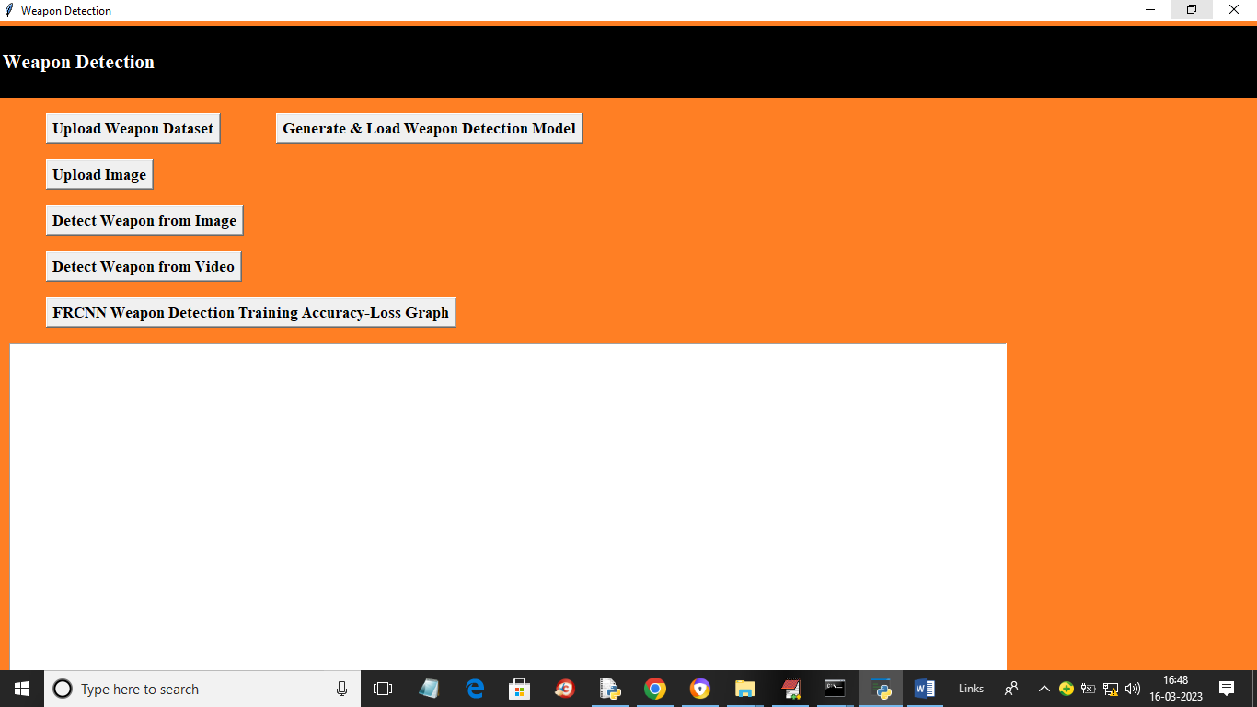
Figure 5.1 : GUI/Main Interface of A Deep Learning-Based Approach for
Weapon detection using FRCNN

Loaded Sample Image :
In below screen, selecting and uploading entire ‘Dataset’ folder and then click on ‘Select Folder’ button to load dataset.


Figure 5.2.1 : Loaded sample image of A Deep Learning-Based Approach for weapon detection using FRCNN.

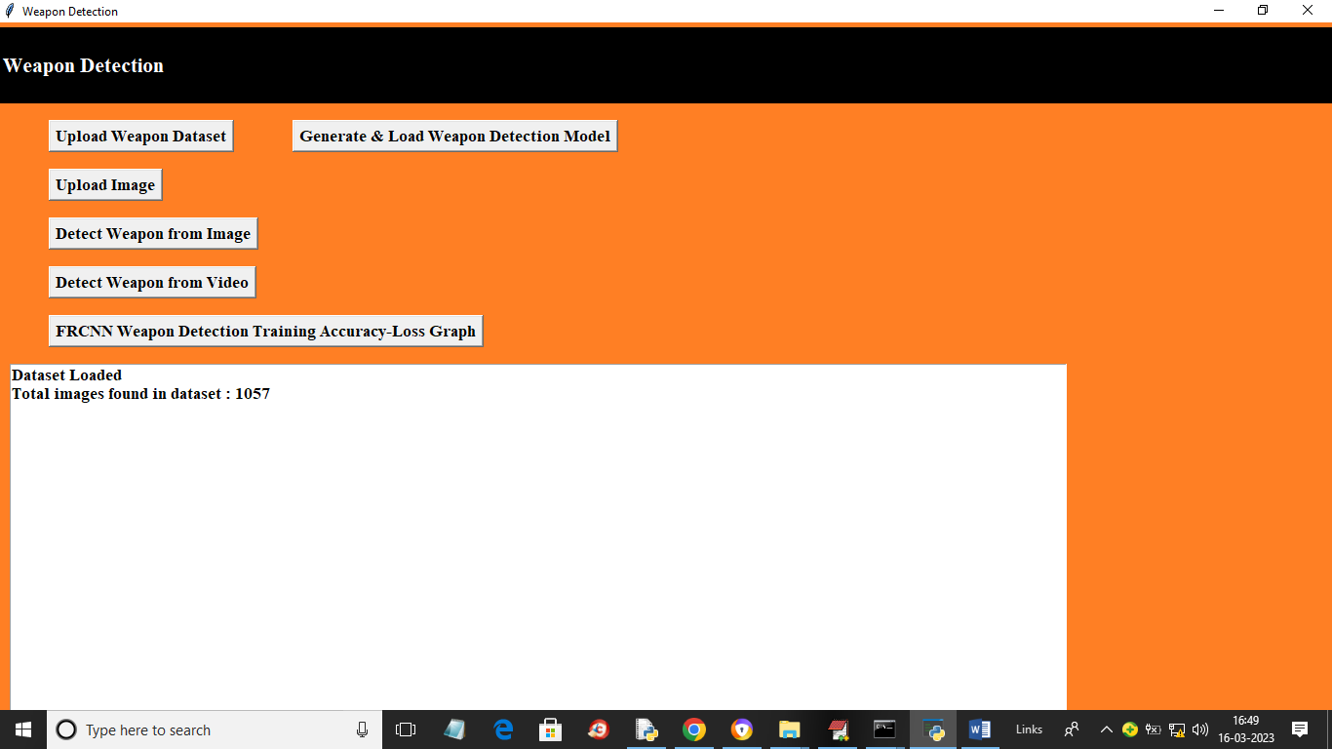
Figure 5.2.2 : The dataset images are uploaded and sent used for model training.

5.3 Dataset Processing :
Once the dataset is loaded, the system processes all images automatically. This includes resizing images, normalizing pixel values, and organizing data for training. This preprocessing step improves the accuracy and efficiency of the model.
5.4 Model Training :
Click on ‘Generate & Load Weapon Detection Model’ to train the Faster R-CNN model using the uploaded dataset. During training, the model learns to identify weapon features and improves its detection capability.
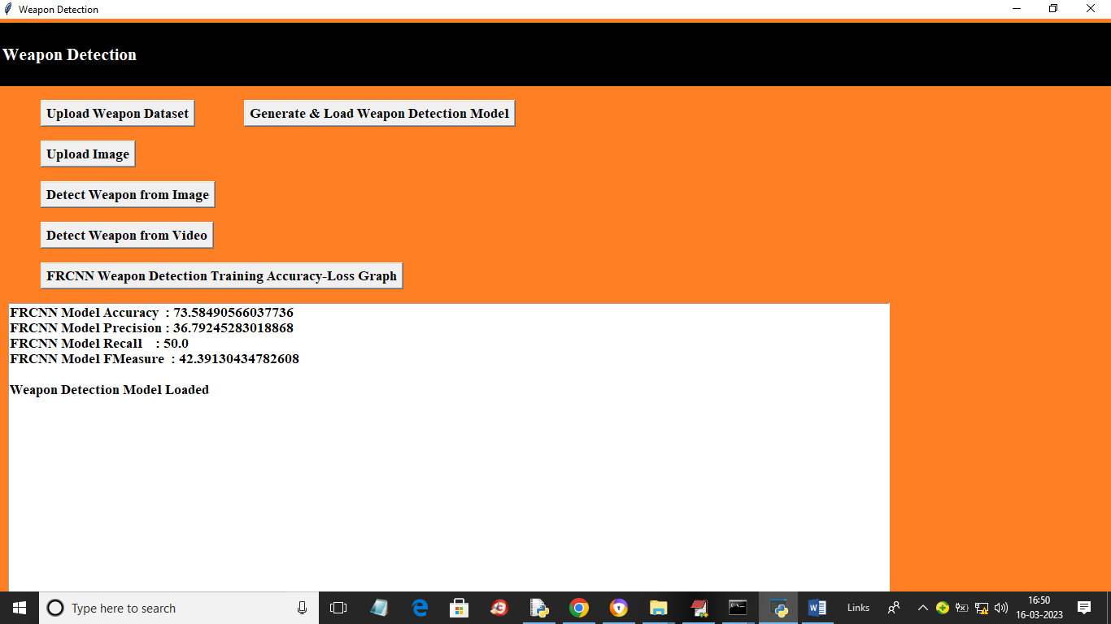
Figure 5.4 : It shows he different parameters percentages including accuracy and precision.

5.5 Accuracy and Loss Graph :
After training is completed, click on ‘FRCNN Weapon Detection Training Accuracy-Loss Graph’ to view the performance metrics. The graph shows how accuracy increases and loss decreases during training, indicating model performance.

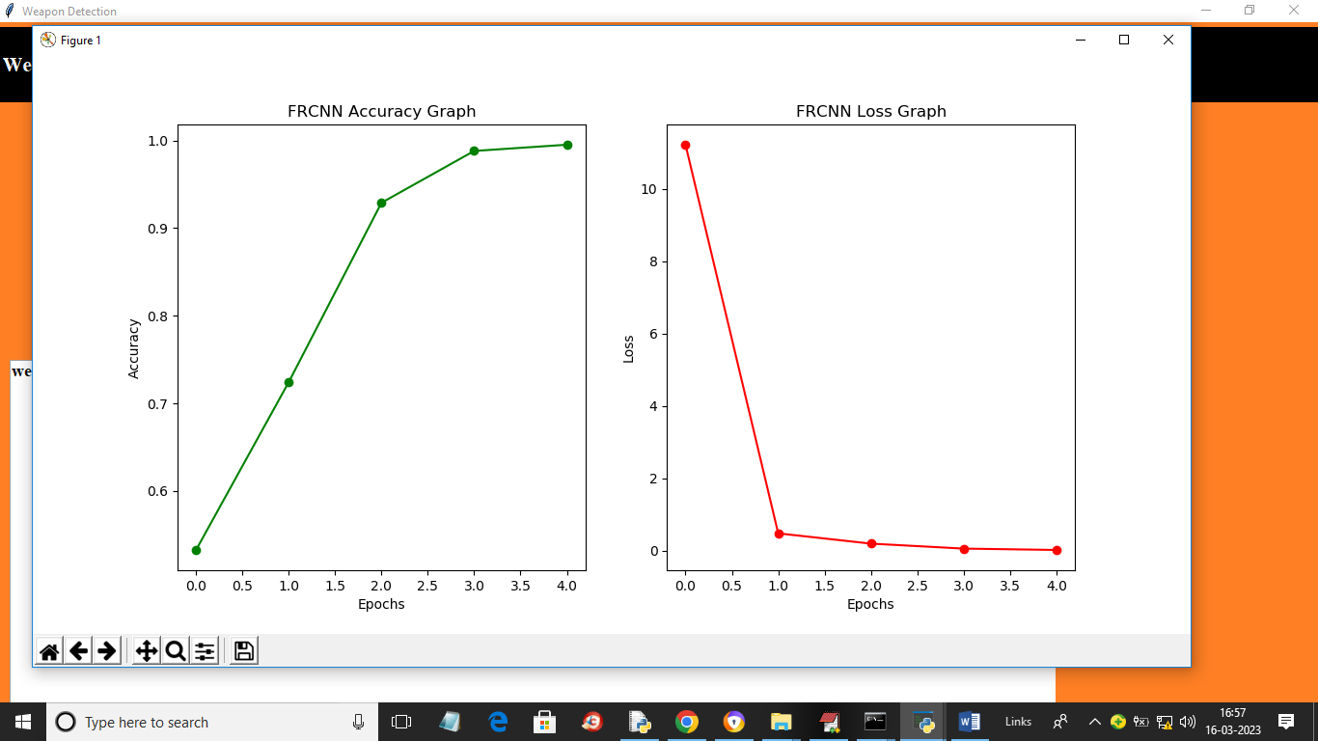
Figure 5.5 :In above training graphs x-axis represents training EPOCH and y-axis represents accuracy and loss values and green line represents accuracy and red line represents LOSS.
5.6 Upload Image :
To test the system, click on the ‘Upload Image’ button and select an image file. This allows the user to check whether the system can correctly detect weapons in a given image.
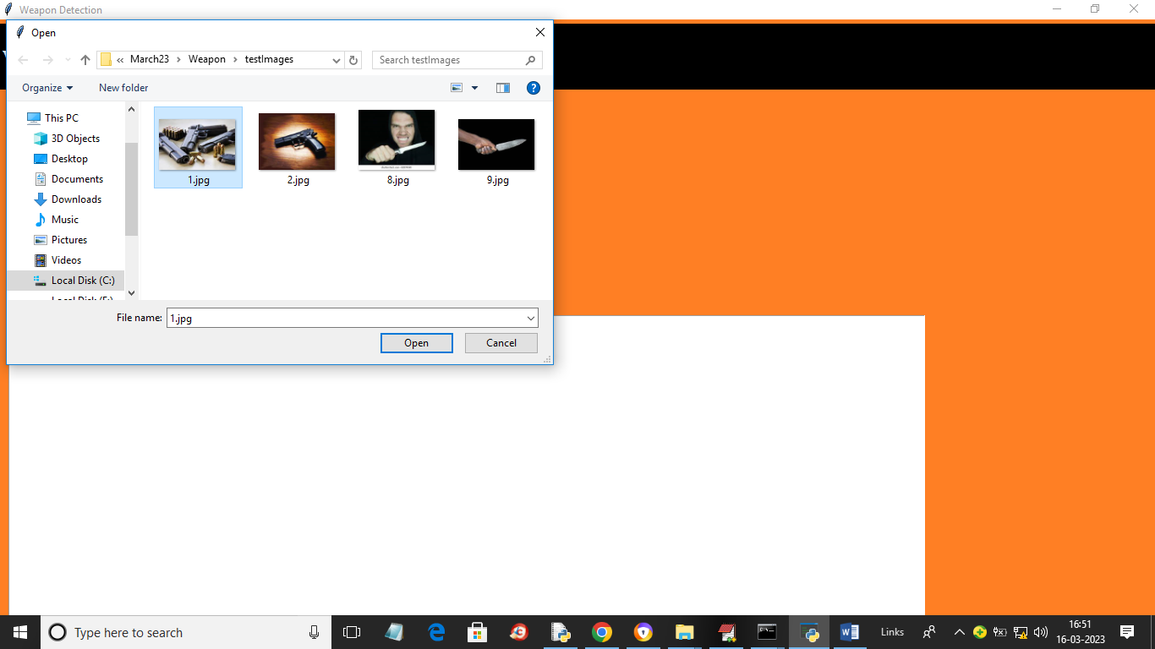
Figure 5.6 : It represents uploading random images for weapon detection model using FRCNN

5.7 Weapon Detection from Image :
After uploading the image, click on ‘Detect Weapon from Image’ to perform detection. The system analyzes the image and highlights detected weapons with bounding boxes and confidence scores.
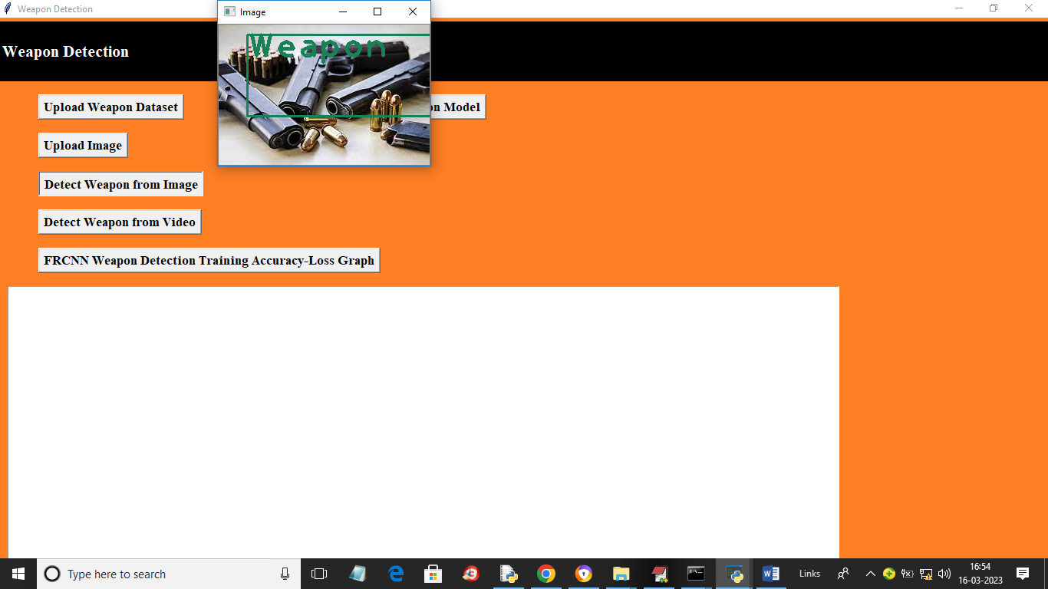
FIgure 5.7 : Represents the out of the image i.e weapon detection
5.8 Weapon Detection from Video :
Click on ‘Detect Weapon from Video’ to upload a video file. The system processes the video frame by frame and detects weapons in real time or near real time.

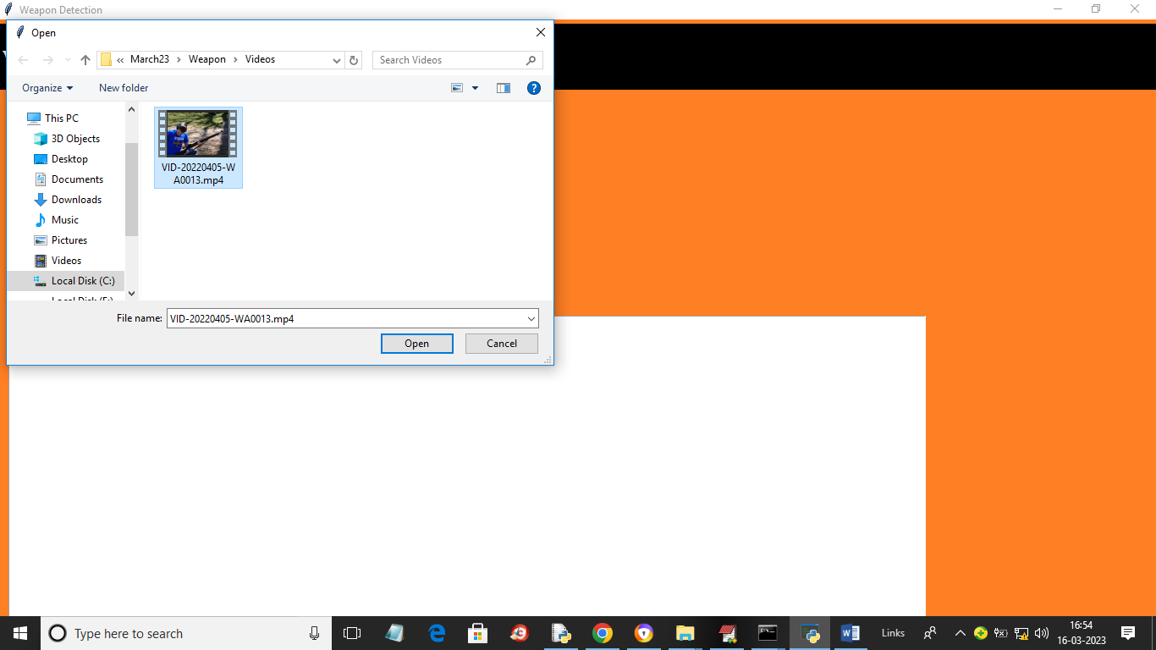
Figure 5.8 : It showing uploading of a video for weapon detection..
5.9 Output Display :
The final output is displayed on the interface, showing detected weapons clearly marked. Users can test multiple images and videos, making the system reliable and easy to use for practical applications.
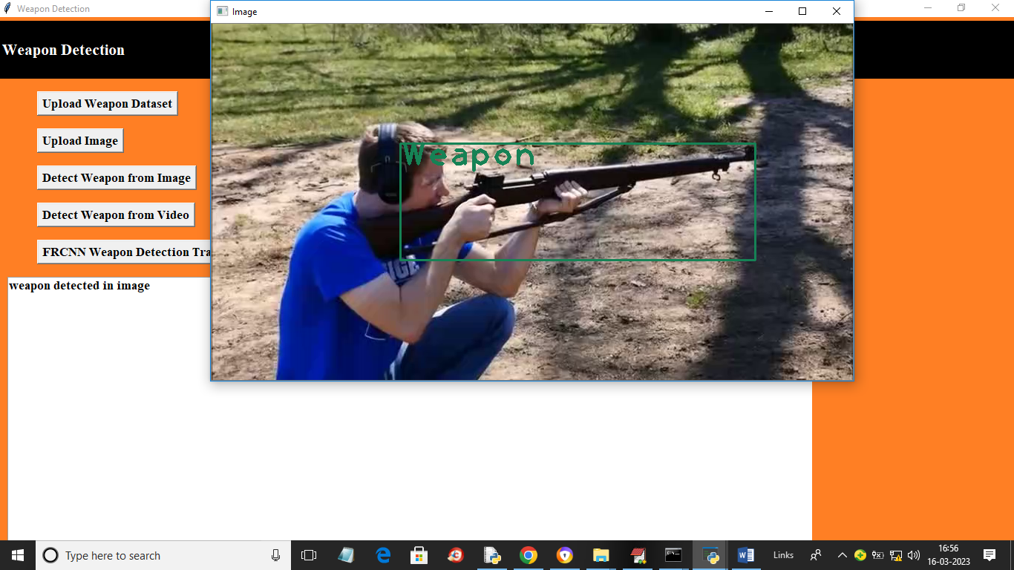
Figure 5.9 : Represents output i.e weapon detected from a video frame by frame.

6.VALIDATION

6.VALIDATION
The validation of this project is carried out through a comprehensive testing process to ensure the accuracy, reliability, and effectiveness of the weapon detection system. It involves multiple stages such as dataset validation, model evaluation, and real-time testing. A well-structured validation approach helps in identifying system limitations, reducing errors, and improving overall performance in detecting weapons.
6.1 INTRODUCTION
Initially, the dataset is divided into training and testing sets, typically using an 80-20 split. The training dataset is used to train the Faster R-CNN model, enabling it to learn important features related to weapons. The testing dataset is used to evaluate the model’s performance on unseen data, ensuring that it can generalize well to real-world scenarios. This process helps in avoiding overfitting and improves model reliability.
To further enhance validation, different evaluation techniques are applied. The system performance is measured using key metrics such as accuracy, precision, recall, and F1-score. These metrics provide a detailed understanding of how well the model detects weapons and minimizes incorrect predictions. The confusion matrix is also used to analyze true positives, true negatives, false positives, and false negatives, helping in refining the model.
The proposed Faster R-CNN model is also compared with other possible approaches to highlight its effectiveness. Such comparisons demonstrate that deep learning-based object detection models provide better accuracy and localization compared to traditional methods. This ensures that the system performs efficiently in complex environments.
Finally, real-world testing is conducted using images and video streams to simulate practical surveillance conditions. The system processes input data in real time and detects weapons with bounding boxes and confidence scores. Continuous testing and performance monitoring allow improvements to be made, ensuring that the system remains accurate, scalable, and suitable for deployment in real-world security applications.

6.2.4 Test Cases :
Test Case Id | Test Case Name | Test Case Desc. | Test Steps |  |  |  | Test Case Status | Test Priority
 |  |  | Step | Expected |  | Actual
O1 | upload weapon dataset | Upload the weapon dataset | If weapon Dataset is not uploaded we cannot do anything | we cannot do any further operations | we can do further operations |  | High | High
02 | create & load weapon detection model | Verify model created or not | If modelnot is not done | we cannot do any further operations | we can do further operations |  | High | High
03 | upload images | Verify images are uploaded or not | If uploading is not done | We cannot run  operation | We can Run the Operation |  | High | High
04 | detect weapon from images | Verify the weapon detection | If detection is not done | We cannot run  operation | We can Run the Operation |  | High | High
05 | detect weapon from video | Verify the weapon detection from video | If detection is not done | We cannot run another  operation | We can Run the Operation |  | High | High
06 | FRCNN weapon detection training accuracy, Loss graph | Cheque the graph is plotted or not | It graph is not plotted | We cannot run another  operation | We can Run the Operation |  | High | High

7.CONCLUSION

&

FUTURE ASPECTS
7.CONCLUSION & FUTURE ASPECTS:
In conclusion, the project has successfully achieved its objective of developing an efficient weapon detection system using deep learning techniques. The system was carefully designed and implemented to detect weapons in images and video streams with high accuracy. By utilizing advanced object detection algorithms, the project demonstrates improved performance over traditional methods and reduces the need for manual monitoring in surveillance systems.
Looking ahead, the future scope of this project is promising. Enhancements can be made by integrating more advanced models, improving real-time processing capabilities, and expanding the dataset for better accuracy. These improvements will make the system more scalable, reliable, and suitable for real-world security applications. Continuous development will ensure the system remains effective in handling evolving security challenges.
7.1 PROJECT CONCLUSION :
This project presents an effective deep learning-based framework for weapon detection using the Faster R-CNN algorithm. The model performs feature extraction, object localization, and classification to accurately detect weapons in images and video frames. By using annotated datasets and advanced training techniques, the system achieves high accuracy and reliable performance.
The Faster R-CNN model overcomes limitations of traditional machine learning approaches by providing precise bounding box detection and better feature representation. It handles variations in lighting, background, and object orientation effectively, making it suitable for real-world applications. The system also reduces false detections and improves decision-making in surveillance scenarios.
The modular design of the system allows easy integration with other security systems and supports scalability for handling large datasets. Overall, the project demonstrates the practical application of deep learning in enhancing public safety and automated surveillance systems.

7.2 FUTURE ASPECTS
The proposed weapon detection system can be further improved by incorporating advanced technologies and expanding its capabilities. Future developments may include real-time deployment using edge devices, integration with CCTV surveillance systems, and optimization for faster processing speed.
Additional improvements can be achieved by increasing dataset diversity, including different types of weapons and complex scenarios. The use of more advanced models such as YOLO or transformer-based detection methods can further enhance performance.
Future research can also focus on improving system accuracy under challenging conditions such as low lighting, occlusion, and crowded environments. Integration with alert systems and automated response mechanisms can make the system more effective for real-world security applications. Continuous learning and model updates will ensure the system adapts to new threats and remains reliable over time.

8.BIBLIOGRAPHY

BIBLIOGRAPHY

REFERENCES

- Wei Liu et al., “SSD: Single Shot MultiBox Detector”, European Conference on Computer Vision, 2017.
- D. Erhan et al., “Scalable Object Detection Using Deep Neural Networks,” IEEE Conference on Computer Vision and Pattern Recognition (CVPR), 2014.
- Ruben J Franklin et al., “Anomaly Detection in Videos for Video Surveillance Applications Using Neural Networks,” International Conference on Inventive Systems and Control, 2020.
- H R Rohit et al., “A Review of Artificial Intelligence Methods for Data Science and Data Analytics: Applications and Research Challenges,” International Conference on I-SMAC, 2018.
- Abhiraj Biswas et al., “Classification of Objects in Video Records using Neural Network Framework,” International Conference on Smart Systems and Inventive Technology, 2018.
- Pallavi Raj et al., “Simulation and Performance Analysis of Feature Extraction and Matching Algorithms for Image Processing Applications,” IEEE International Conference on Intelligent Sustainable Systems, 2019.
- Mohana et al., “Simulation of Object Detection Algorithms for Video Surveillance Applications,” International Conference on I-SMAC, 2018.
- Yojan Chitkara et al., “Background Modelling Techniques for Foreground Detection and Tracking using Gaussian Mixture Model,” International Conference on Computing Methodologies and Communication, 2019.
- Rubner et al., “A Metric for Distributions with Applications to Image Databases,” International Conference on Computer Vision, 2016.
- N. Jain et al., “Performance Analysis of Object Detection and Tracking Algorithms for Traffic Surveillance Applications using Neural Networks,” International Conference on I-SMAC, 2019.
- A. Glowacz et al., “Visual Detection of Knives in Security Applications using Active Appearance Model,” Multimedia Tools and Applications, 2015.
- S. Pankanti et al., “Robust Abandoned Object Detection using Region-Level Analysis,” International Conference on Image Processing, 2011.
- Ayush Jain et al., “Survey on Edge Computing - Key Technology in Retail Industry,” International Conference on Intelligent Computing and Control Systems, 2019.

- Mohana et al., “Performance Evaluation of Background Modeling Methods for Object Detection and Tracking,” International Conference on Inventive Systems and Control, 2020.
- J. Wang et al., “Detecting Static Objects in Busy Scenes,” Technical Report, Cornell University, 2014.
- V. P. Korakoppa et al., “An Area Efficient FPGA Implementation of Moving Object Detection and Face Detection using Adaptive Threshold Method,” International Conference on Recent Trends in Electronics, Information & Communication Technology, 2017.
- S. K. Mankani et al., “Real-Time Implementation of Object Detection and Tracking on DSP for Video Surveillance Applications,” International Conference on Recent Trends in Electronics, Information & Communication Technology, 2016.
8.2 GITHUB LINK :
https://github.com/nithin07-cmd?tab=repositories

